Assessing the ‘movescape’ of giant armadillos (*Priodontes maximus*)

**Background**

Studies have been conducted on the habitat selection of giant armadillos in the Brazilian Pantanal, which is useful to determine which patches are most (or least) suitable for resting and foraging by this species. However, the combination of habitat preference with the speed of giant armadillo movements can help to deduce functional connectivity across the landscape. This is similar to the approach taken by Bastille-Rousseau and Wittemyer (2020) where they characterize a ‘movescape’ (or the functional role of areas for movement across a landscape) using a combination of functional and structural connectivity metrics, as well as intrinsic properties of animal behavior from GPS tracks. We approach the estimation of a ‘movescape’ differently by estimating the time spent per pixel (for a given landscape) and compare these estimates against those of habitat selection. By combining the speed of movement with a measure of habitat selection, we can discriminate between potential corridors of connectivity and high risk areas. Additionally, we can also resolve the difference between patches that provide shelter, protection, or quality forage against areas that impede movement.

**Methods**

GPS tracks were available for 7 individuals (blanca, emanuel, gala, mafalda, mazeboti, sara, tex) sampled at 7 min intervals for varying durations from 2019 – 2020. A sample size of N = 13,396 total observations were analyzed from all 7 IDs.

To estimate habitat selection in these armadillos, I fit a step-selection function (SSF) using land use/land cover (LU/LC) and normalized difference water index (NDWI). SSFs were fit separately by ID to account for different functional responses. LU/LC included classes for Forest, Open Savanna, Closed Savanna, and Floodable, which reflected the general properties of features across the landscape. The “Forest” land class was treated as the reference for LU/LC, which resulted in no beta coefficient being estimated by the SSF (case-control groups treated as intercept). NDWI is a metric of water presence that was extracted on a seasonal basis and was included as a way to account for the dynamic change in wet vs dry areas over time. For the SSF, I sampled 30 control points (i.e., available points) for each case point (i.e., used point). The NDWI covariate was extracted from the associated seasonal raster in which the relocation was sampled. Habitat selection surfaces were calculated across seasons within each animal ID and if similar, were aggregated across seasons (within each ID) and then averaged across IDs. The mean predictive surface of habitat selection across all IDs and the variance across IDs were plotted as well.

The velocity-based resistance model was estimated where time spent per pixel is a function of each of the covariates included within the SSF (LU/LC, NDWI). Separate models were fit by ID to assess individual heterogeneity (i.e., differences in functional responses). If there were minimal differences in resistance surfaces for an individual, an average surface was calculated across all seasons in which a given ID was recorded. To make a population-level estimate of the movescape, a mean resistance surface and its variance were calculated across all IDs.

Given the estimates of habitat selection and time spent per pixel, we explored the movescape in two different ways: 1) by visualizing the metrics plotted on top of one another using different color ramps and 2) by classifying pixels into different categories. When visualizing a scatterplot of the values of habitat selection against time spent per pixel, this could be broken into quadrants where each quadrant represents a different category of movement. These categories were classified as:

1. Fast-Preferred (e.g., corridors for fast movement)
2. Slow-Preferred (e.g., habitat that is used for resting, foraging, or protection)
3. Fast-Avoided (e.g., easy to move through, but risky/dangerous matrix)
4. Slow-Avoided (e.g., habitat that impedes movement)

These categories will then be mapped onto each pixel of the raster to estimate the movescape of the giant armadillos.

Below, maps are shown for the static LU/LC covariate and the dynamic NDWI covariate. Gaps in the Summer raster for NDWI are due to clouds and cloud shadows masked from the Landsat 8 imagery from which this metric was derived. *This could potentially be resolved later on by using finer spatiotemporal scale Sentinel-2 imagery that may fill in these gaps.*

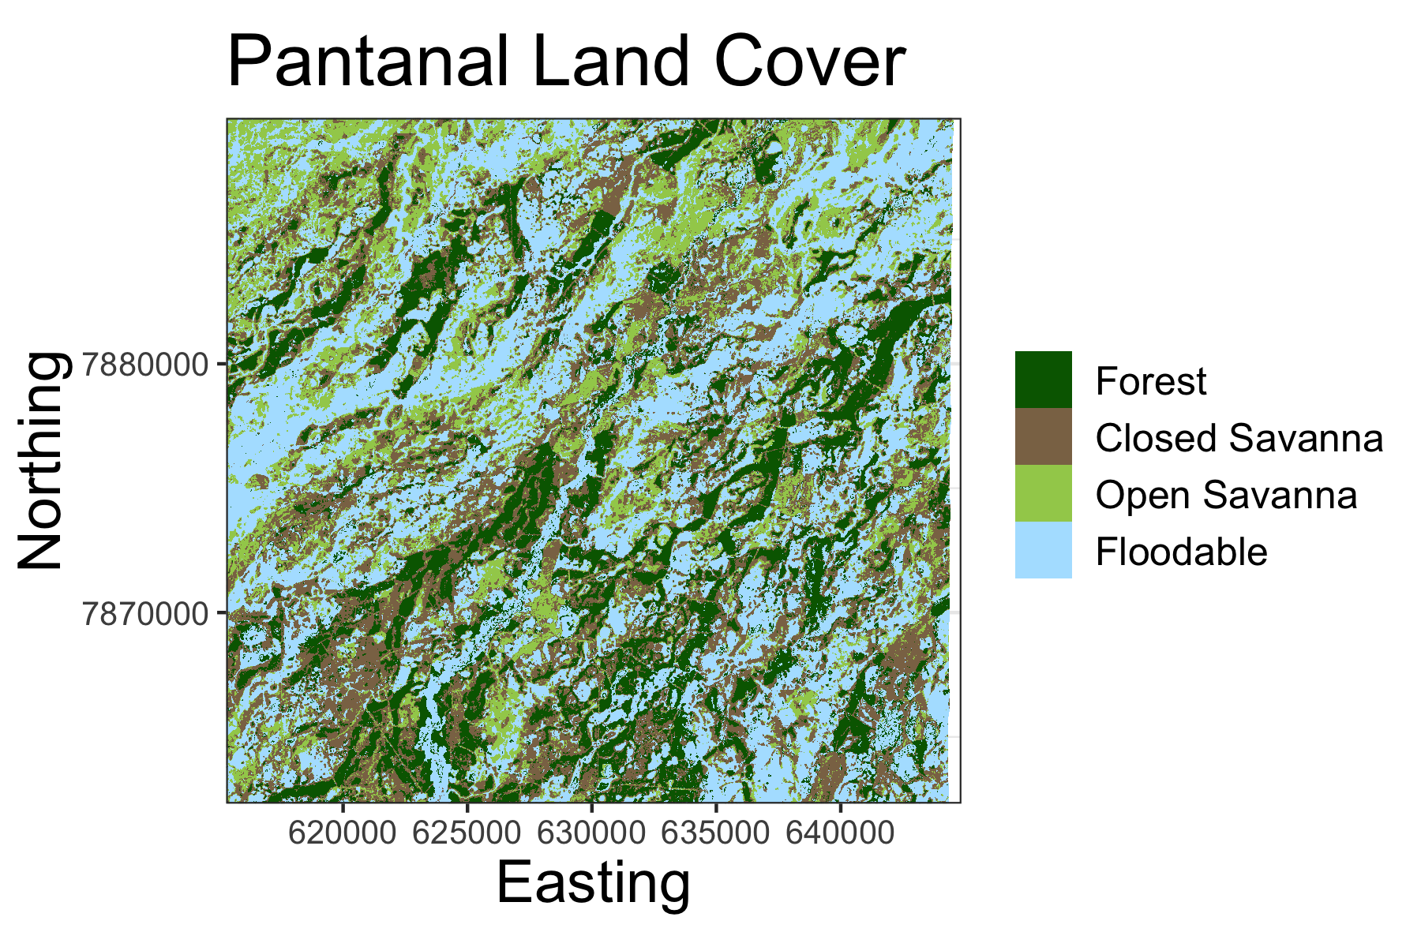

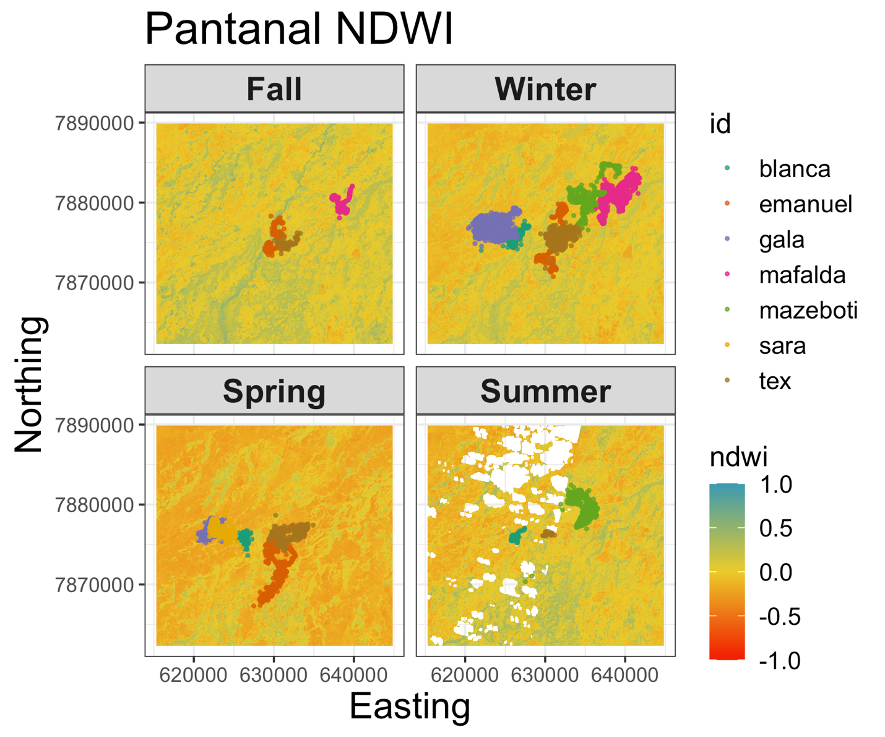

**Results**

*Habitat Selection*

The estimated coefficients from the SSF are plotted below and shown on the logit scale from the conditional logistic regression. Overall, most individuals show consistency in the magnitude and direction of the effect size, where there is a slight negative relationship with NDWI, no preference for “Floodable” habitat, and relatively larger positive relationships with “Open Savanna” and “Closed Savanna” habitats. However, there are a couple instances where an individual exhibits a different response from the rest of the individuals (e.g., gala for NDWI, mafalda for Closed Savanna).

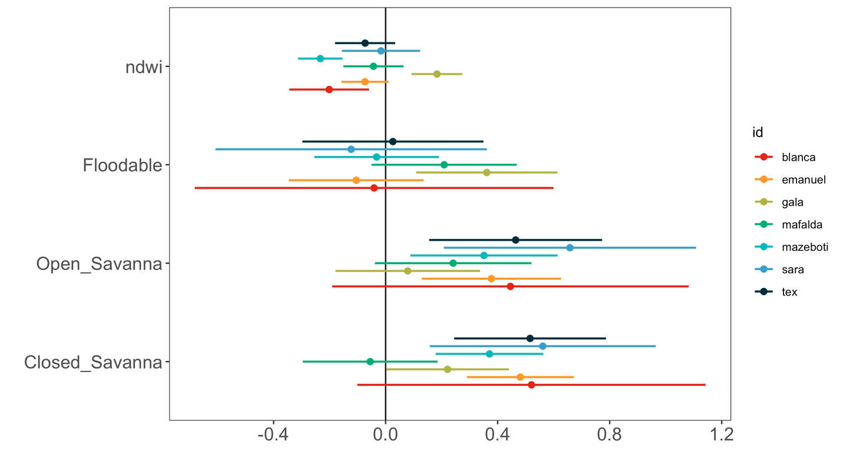

Spatiotemporal predictions of habitat selection are shown on a seasonal basis, but do not exhibit strong differences. Therefore, seasonal predictions were averaged into a single mean layer of habitat selection within each individual. These estimates show a slight preference for Closed and Open Savannas and a slight avoidance of Forest and Floodable areas. Variance estimates of the predictive surface was low overall, but tended to be greater in Floodable areas.

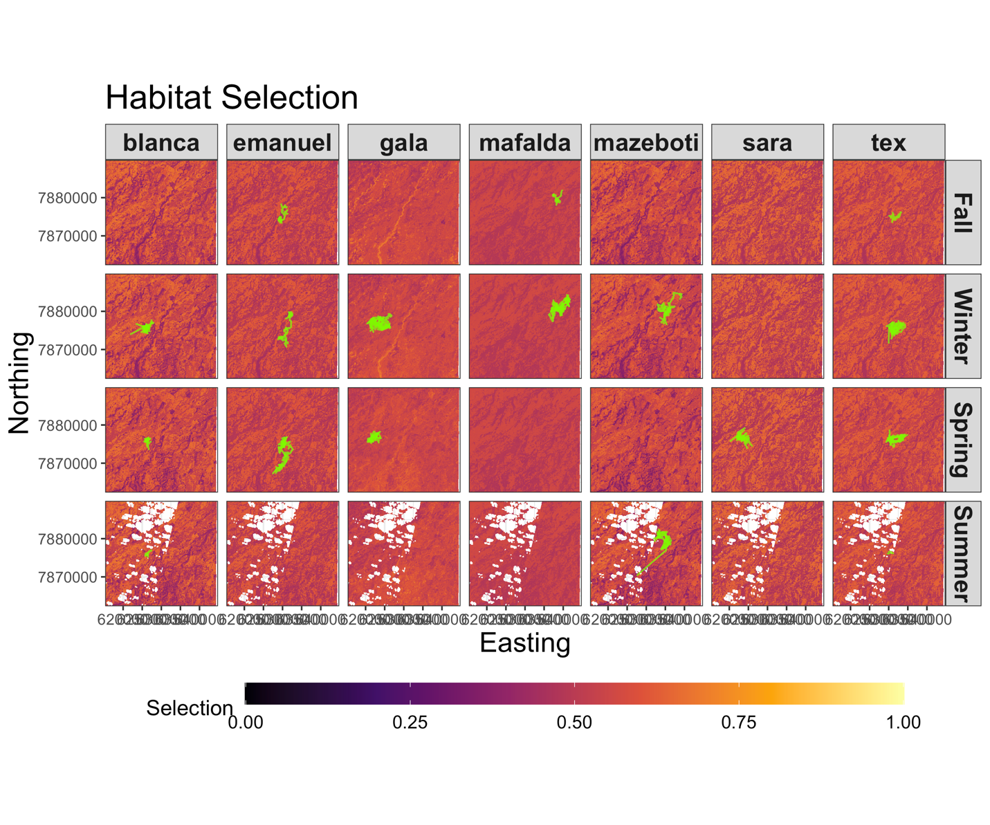

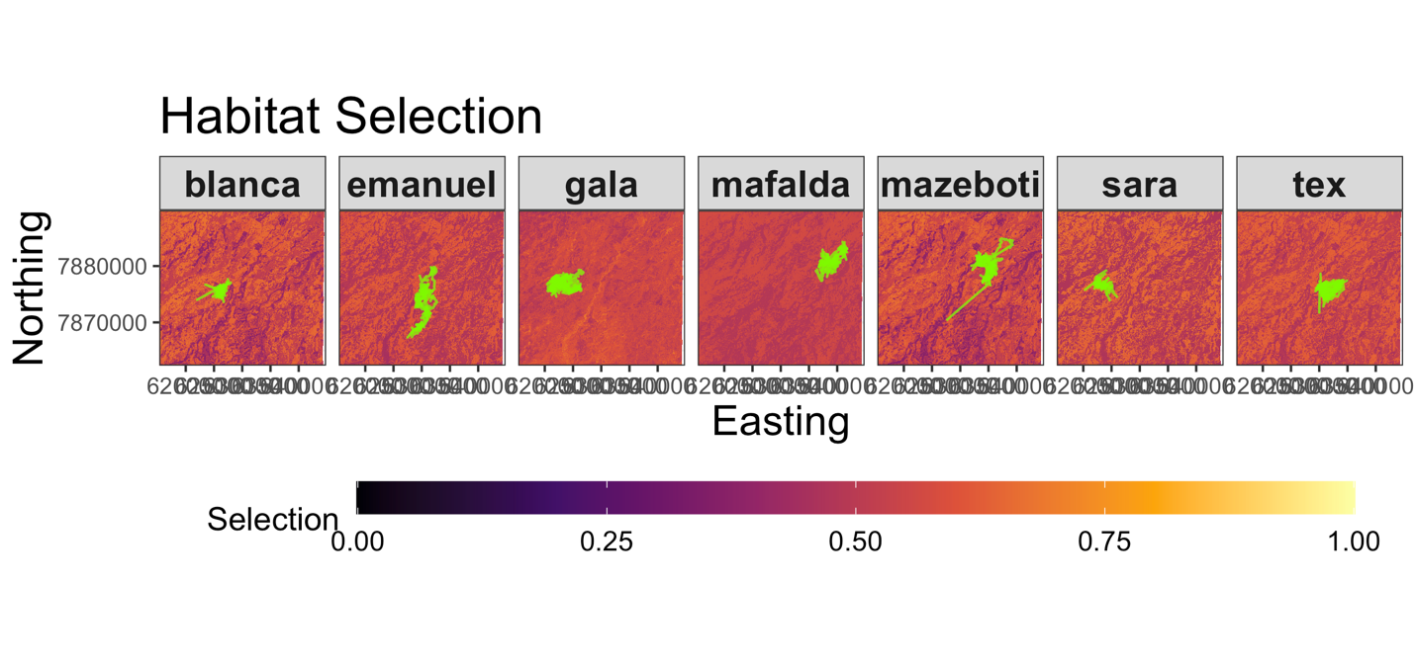

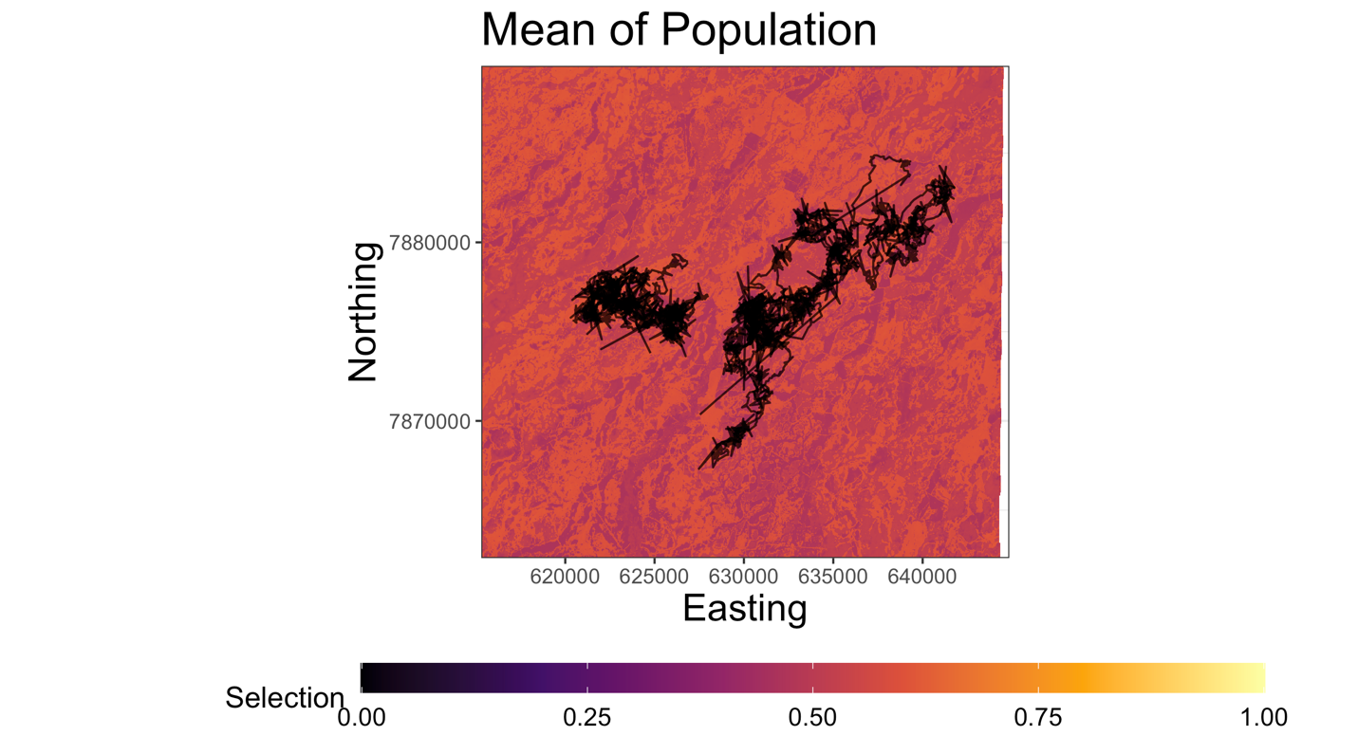

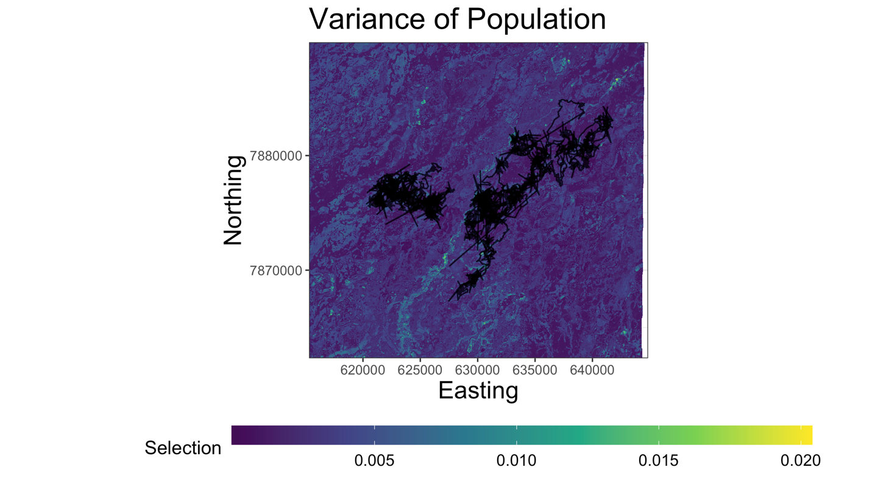

*Landscape Resistance*

There was a relatively high level of individual heterogeneity in functional responses to each of the environmental covariates. However, the greatest heterogeneity occurred for the coefficient estimates of Forest and Floodable land classes. This resulted in spatial estimates of time spent per pixel that varied widely among individuals. However, there was a minimal effect of seasonal impacts since the dynamic variable NDWI had a much lower coefficient than for any of the land classes on average. Therefore, our measures of resistance (i.e., time per pixel) were averaged across seasons within each ID. A population mean and variance were calculated across individuals to reduce dimensionality of the data. The fastest movements (i.e., least time spent per pixel) was in Floodable and Forest habitat, whereas slower movements were observed in Closed and Open Savannas.

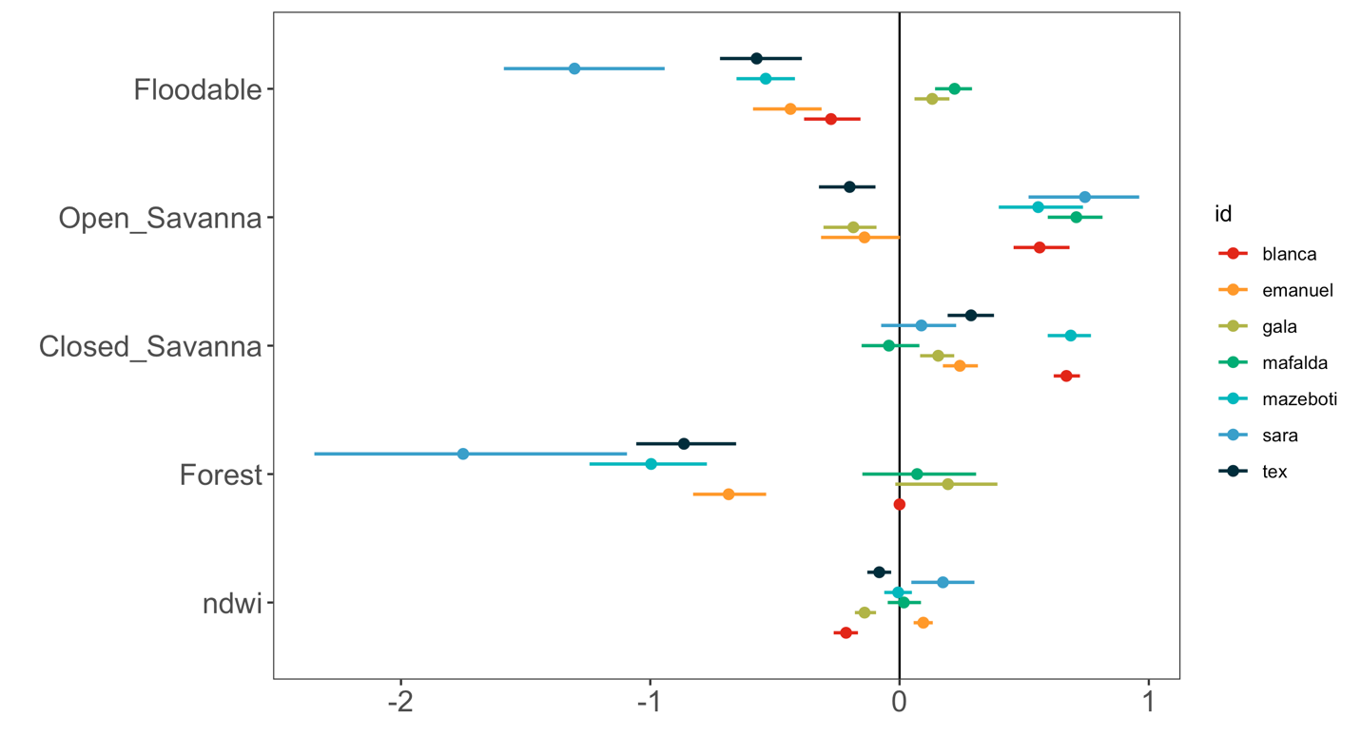

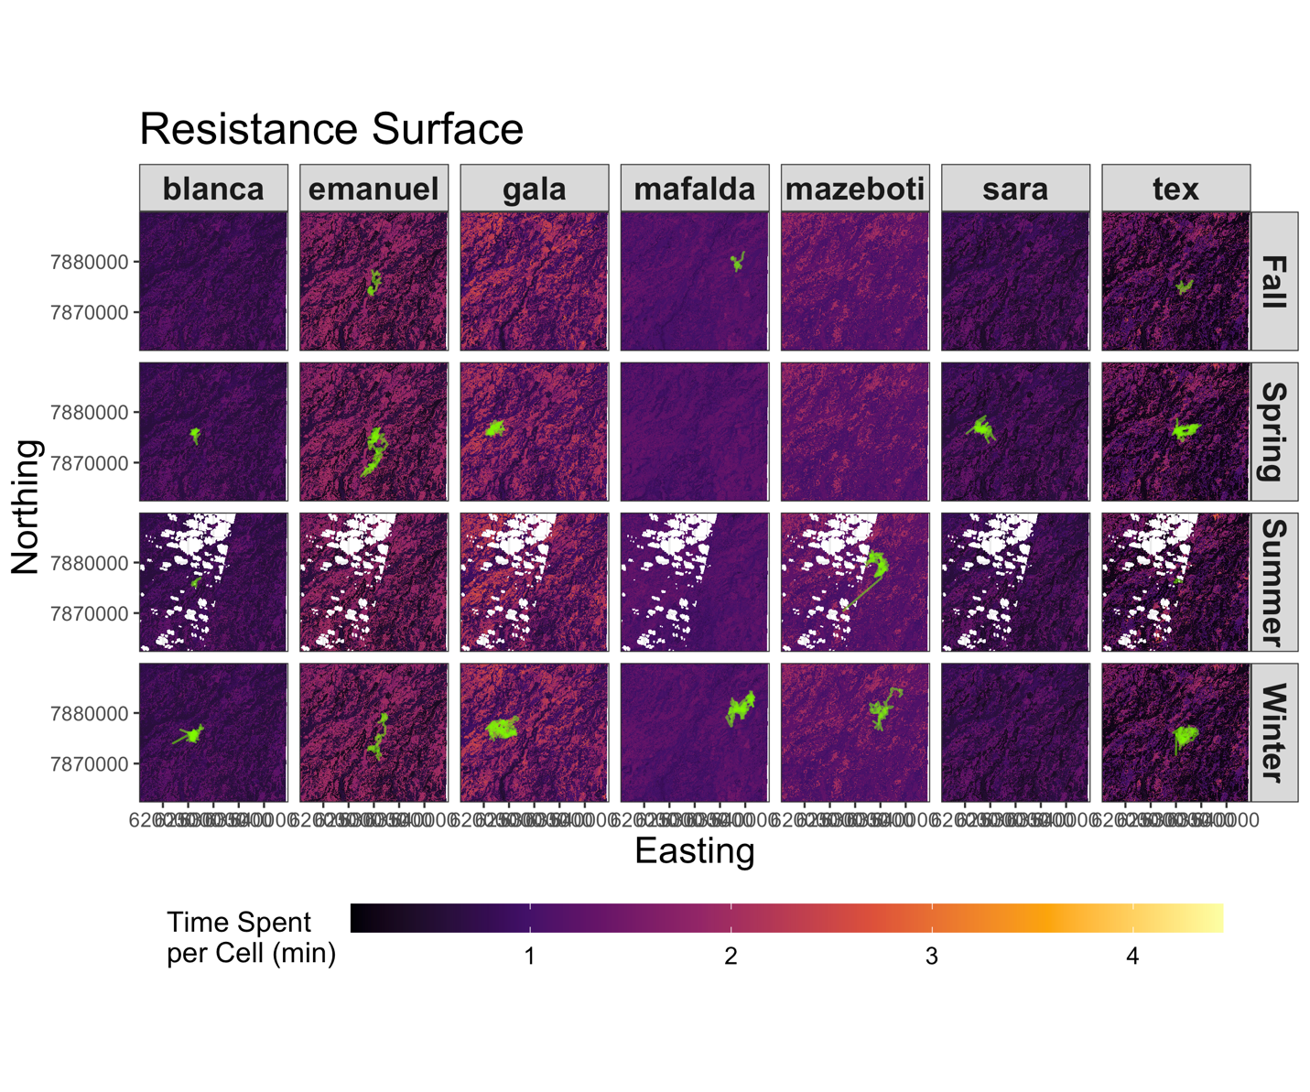

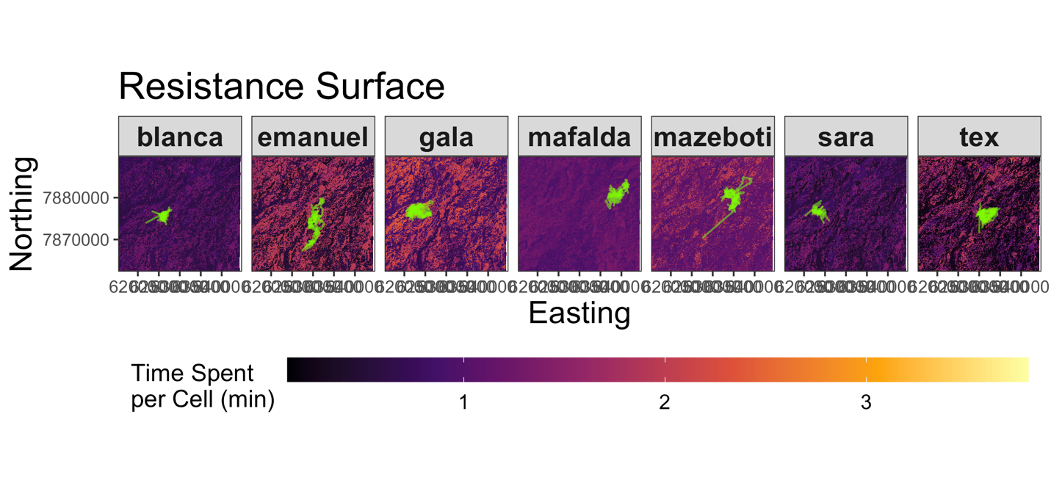

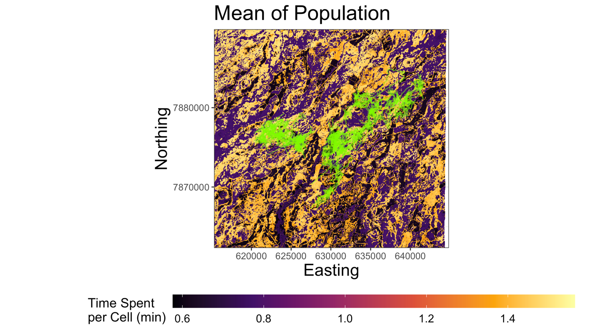

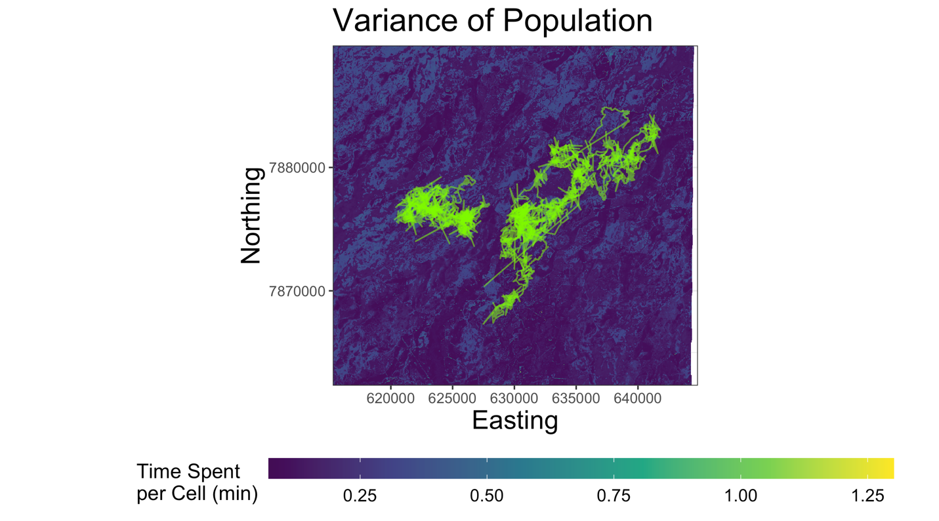

*Integration of Speed and Habitat Selection for Movescape*

Once estimates of armadillo speed and habitat selection were calculated, these were combined to make inference on the ‘movescape’. Below are plots that compare both sets of estimates and break them into a set of quadrants. These quadrants represent each of the four previously mentioned categories of functional connectivity classifications. Each point represent a single pixel across the study region and they are color-coded by either LU/LC class. From these plots, points (i.e., pixels) are re-classified based on the quadrant in which it falls and then mapped back onto the landscape. Alternatively, they were also plotted using two different monochromatic palettes that can were blended together for a more nuanced interpretation.

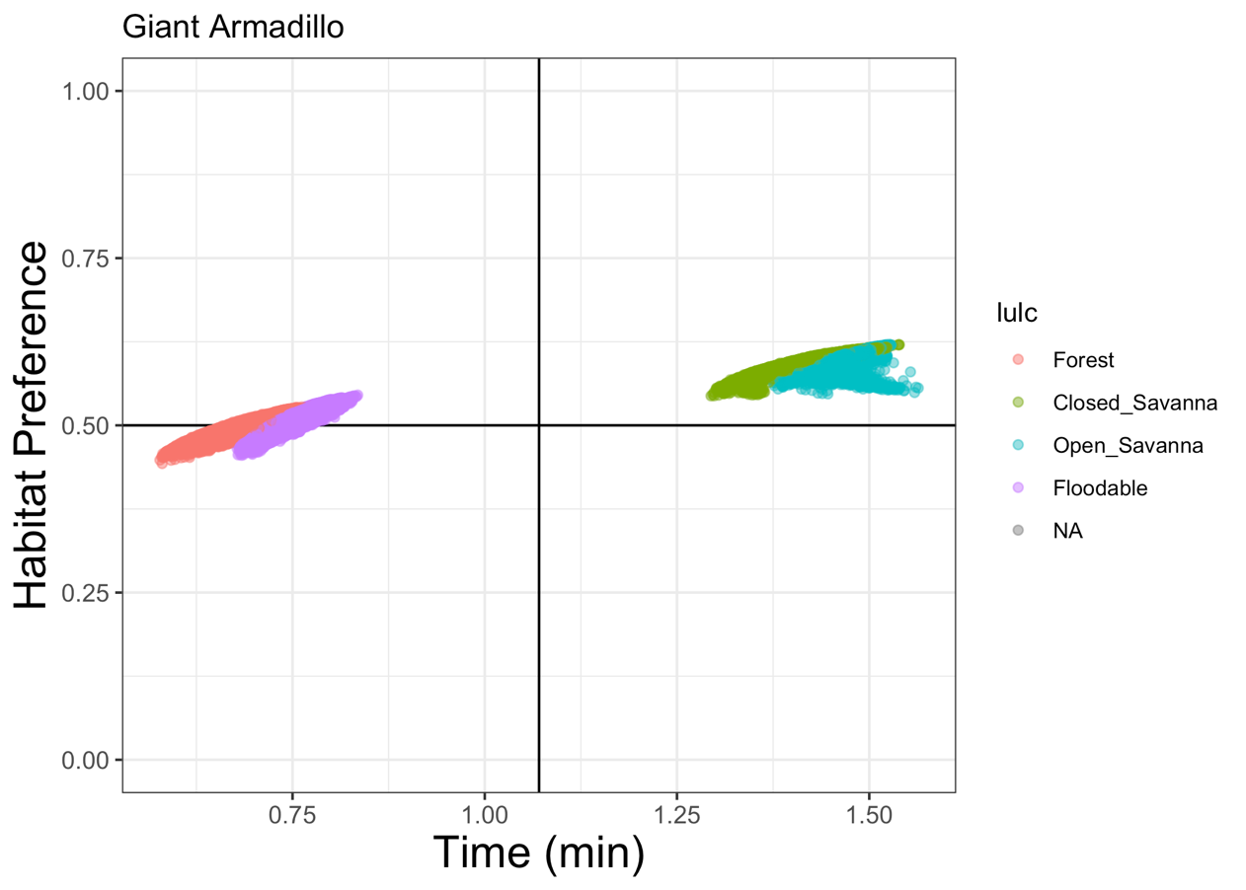

**Slow-Avoided**

**Fast-Avoided**

**Fast-Preferred**

**Slow-Preferred**

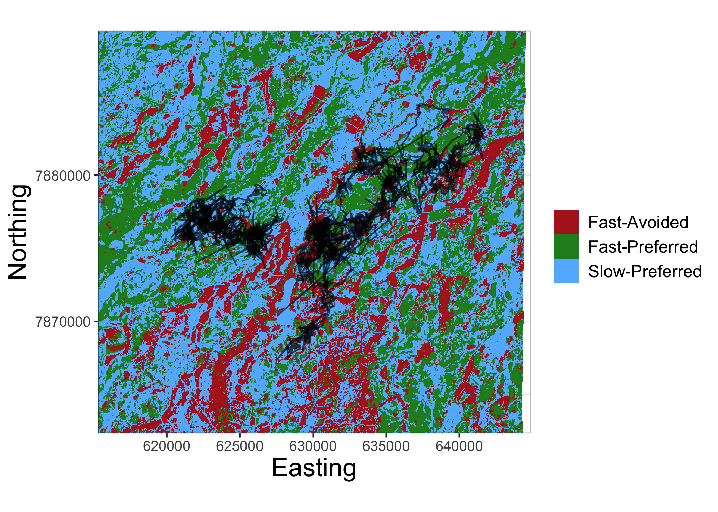

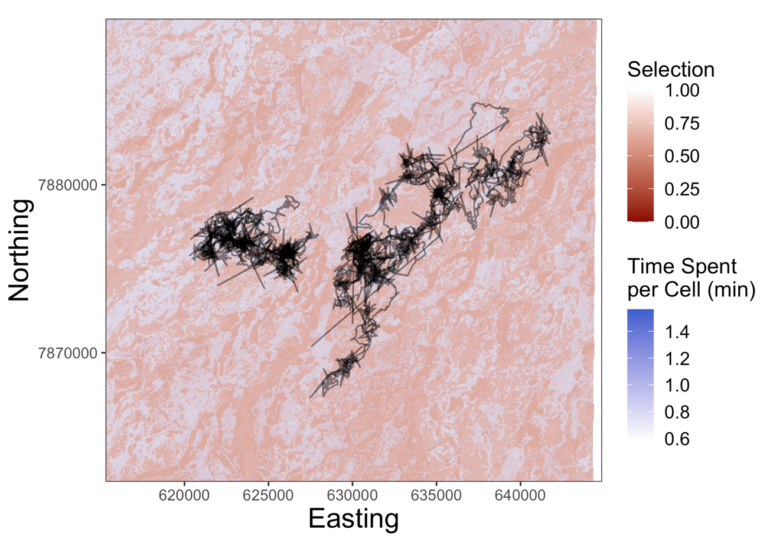

**Discussion**

While these results do appear to provide a simple way to understand movements of giant armadillos, they would likely be improved by making some modifications in the methods to account for the relatively high level of individual heterogeneity when estimating the ‘movescape’ rather than taking a simple average. This may involve fitting separate models per ID and season for SSFs and resistance estimates and using different weighting procedures. This could potentially be performed similarly to methods applied in Osipova et al. (2019) and Zeller et al. (2019) where pixel values are weighted based on the geographic location of each ID. Additionally, the inclusion of a greater number of individuals sampled at other locations and seasons throughout the study region is also likely to improve the inferences made. The estimates of NDWI could also potentially be improved by using Sentinel-2 satellite imagery to calculate NDWI rather than Landsat 8 since Sentinel-2 captures images at a 10m (vs a 30 m) spatial resolution and at a 5 day (vs a 16 day resolution. This would result in fewer images with cloud cover that could be used to calculate seasonal band values, which would likely fill in the gaps in the estimates of summer NDWI. These steps and others (e.g., multi-spatial scale analyses) can be taken to improve these results to estimate dynamic landscape connectivity in giant armadillos.

**References**

Bastille‐Rousseau, G., & Wittemyer, G. (2020). Characterizing the landscape of movement to identify critical wildlife habitat and corridors. *Conservation Biology*.

Osipova, L., Okello, M. M., Njumbi, S. J., Ngene, S., Western, D., Hayward, M. W., & Balkenhol, N. (2019). Using step‐selection functions to model landscape connectivity for African elephants: accounting for variability across individuals and seasons. *Animal Conservation*, *22*(1), 35-48.

Zeller, K. A., Wattles, D. W., Conlee, L., & DeStefano, S. (2019). Black bears alter movements in response to anthropogenic features with time of day and season. *Movement ecology*, *7*(1), 19.